**Exercise 3: E-commerce Platform Search Function**

**Scenario:**

You are working on the search functionality of an e-commerce platform. The search needs to be optimized for fast performance.

**Steps:**

1. **Understand Asymptotic Notation:**
   * Explain Big O notation and how it helps in analyzing algorithms.
   * Describe the best, average, and worst-case scenarios for search operations.
2. **Setup:**
   * Create a class **Product** with attributes for searching, such as **productId, productName**, and **category**.
3. **Implementation:**
   * Implement linear search and binary search algorithms.
   * Store products in an array for linear search and a sorted array for binary search.
4. **Analysis:**
   * Compare the time complexity of linear and binary search algorithms.
   * Discuss which algorithm is more suitable for your platform and why.

### What is Big O Notation?

**Big O notation** describes the **performance or complexity** of an algorithm in terms of **input size n.**

| **Case** | **Meaning** |
| --- | --- |
| **Best** | Fastest scenario (e.g., item is first in list) |
| **Average** | Typical scenario (e.g., item is somewhere in the middle) |
| **Worst** | Slowest scenario (e.g., item is last or not found at all) |

**Linear Search vs Binary Search:**

| **Algorithm** | **Best Case** | **Average Case** | **Worst Case** | **Requirements** |
| --- | --- | --- | --- | --- |
| Linear Search | O(1) | O(n/2) → O(n) | O(n) | Unsorted data |
| Binary Search | O(1) | O(log n) | O(log n) | 🔑 Requires **sorted** data |

**Product.java:**

class Product {

int productId;

String productName;

String category;

public Product(int productId, String productName, String category) {

this.productId = productId;

this.productName = productName;

this.category = category;

}

@Override

public String toString() {

return "Product{" +

"productId=" + productId +

", productName='" + productName + '\'' +

", category='" + category + '\'' +

'}';

}

}

**SearchDemo.java**

public class SearchDemo {

public static Product linearSearch(Product[] products, int targetId) {

for (Product product : products) {

if (product.productId == targetId) {

return product;

}

}

return null;

}

public static Product binarySearch(Product[] products, int targetId) {

int left = 0;

int right = products.length - 1;

while (left <= right) {

int mid = left + (right - left) / 2;

if (products[mid].productId == targetId) {

return products[mid];

} else if (products[mid].productId < targetId) {

left = mid + 1;

} else {

right = mid - 1;

}

}

return null;

}

public static void main(String[] args) {

Product[] products = {

new Product(101, "Mobile Phone", "Electronics"),

new Product(202, "T-shirt", "Apparel"),

new Product(303, "Laptop", "Electronics"),

new Product(404, "Headphones", "Accessories"),

new Product(505, "Shoes", "Apparel")

};

Product[] sortedProducts = {

new Product(101, "Mobile Phone", "Electronics"),

new Product(202, "T-shirt", "Apparel"),

new Product(303, "Laptop", "Electronics"),

new Product(404, "Headphones", "Accessories"),

new Product(505, "Shoes", "Apparel")

};

int targetId = 303;

Product linearResult = linearSearch(products, targetId);

System.out.println("Linear search result: " + linearResult);

Product binaryResult = binarySearch(sortedProducts, targetId);

System.out.println("Binary search result: " + binaryResult);

}

}

**OUTPUT:**

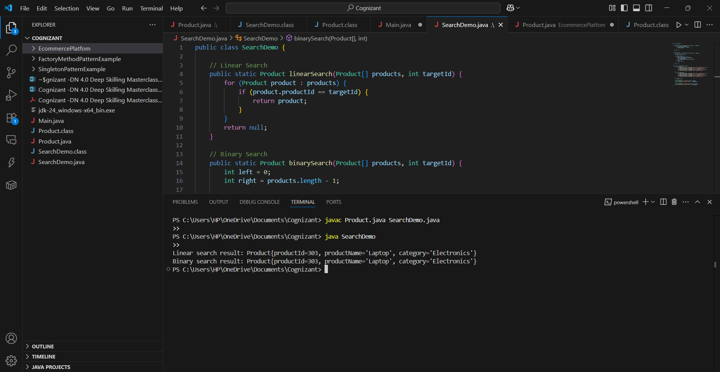

**Analysis & Recommendation**

| **Metric** | **Linear Search** | **Binary Search** |
| --- | --- | --- |
| Time Complexity | O(n) | O(log n) |
| Space Complexity | O(1) | O(1) |
| Data Requirement | Can work on **unsorted** | Requires **sorted** data |
| Implementation | Simple | Slightly complex |

**Which Algorithm is better and Why?**

For **E-commerce platforms** (large product catalog):

* Use **Binary Search** on **sorted lists**
* For huge data: use **HashMap** or **search indexing** (e.g., ElasticSearch)

**Binary Search** is preferred for sorted lists of limited size. For production, you'll use more advanced indexing.